**Contact App**

The use case is to maintain contact details of users, where as a user you could able to

1. Register
2. Login
3. Edit Profile
4. Add Contacts
5. Edit Contacts
6. View Contacts
7. Delete Contacts
8. Delete Profile

Use Case Diagram

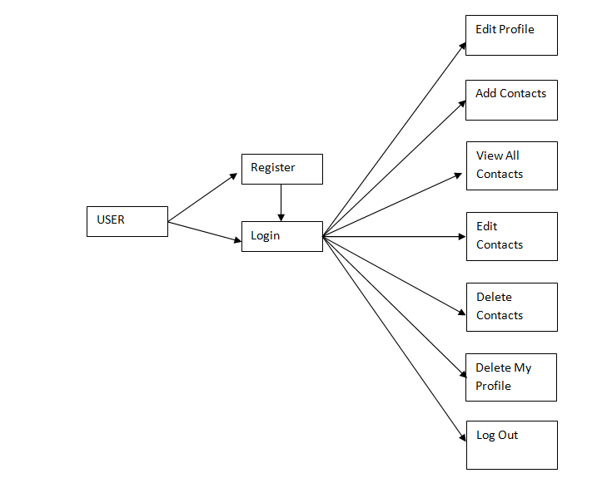

Business Requirement

1. User must be able to register his details first before he could login.
2. Register:
   1. User enters his name, password, phone number, date of birth which is recorded in the database and an unique id which is treated as a profile id will be auto-generated and will be shown to the user to login with the valid password
   2. Perform the validation on the input so that none of the details are empty
   3. After successful registration you could able to see the login page with the generated profile id
3. Login:
   1. User can login by entering profile id and password if he has already registered
   2. Login page shows the profile id only for the newly registered user, so that they will know what is the profile id
   3. Perform the validation on the input so that none of the fields are empty
   4. If login credentials are wrong, re-direct back to the Login page and ask the user to enter valid credentials
   5. If login credentials are right, go to the success page where user could able to perform operations shown in the above use case diagram like add contacts, delete contacts and etc.
4. Add Contact:
   1. Logged in user will store new contact details like name and phone number
   2. When a user adds the new contact an unique contact id will be generated which may require to manipulate the contact details
   3. Contact details are stored along with the logged in user profile id
5. View All Contacts:
   1. Shows all the contacts of a logged in user in an HTML table
6. Edit Profile:
   1. Logged in user must able to update his phone number, password
7. Edit Contacts:
   1. Logged in user must able to edit his corresponding contact book like phone number, name (If Alex is the person logged in and he has some people in his contact book like Bruce or Charles, then Alex must able to edit their details like name, phone number, edit via contact_id and profile_id)
8. Delete Contact:
   1. Logged in user could able to delete people from his contact book
   2. Deletion of contact done via contact id to avoid the deletion of other profile contacts
9. Delete Profile:
   1. Logged in user must able to delete his profile permanently
   2. Automatically all his contact book entries must be deleted before performing the deletion of the profile
10. Log Out
    1. Terminate the session and redirect back to welcome page

* Follow MVC architecture
* Handle Exceptions and propagate them to different layers wherever necessary
* Create appropriated methods in Service & DAO as per the business requirement
* Display appropriate error messages wherever necessary
* Apply styles for View (Don’t waste too much time on styling basic style is fine)
* Create database tables according to the requirement and add primary key, foreign key wherever required (this use case needs two tables)